Packet Tracer - Implement VLANs and Trunking

|  |  |
| --- | --- |
| **Name:** | Danica Marie A. Dumalagan |
| **Date:** | February 10, 2023 |

# Addressing Table

| Device | Interface | IP Address | Subnet Mask | Switchport | VLAN |
| --- | --- | --- | --- | --- | --- |
| PC1 | NIC | 192.168.10.10 | 255.255.255.0 | SWB F0/1 | VLAN 10 |
| PC2 | NIC | 192.168.20.20 | 255.255.255.0 | SWB F0/2 | VLAN 20 |
| PC3 | NIC | 192.168.30.30 | 255.255.255.0 | SWB F0/3 | VLAN 30 |
| PC4 | NIC | 192.168.10.11 | 255.255.255.0 | SWC F0/1 | VLAN 10 |
| PC5 | NIC | 192.168.20.21 | 255.255.255.0 | SWC F0/2 | VLAN 20 |
| PC6 | NIC | 192.168.30.31 | 255.255.255.0 | SWC F0/3 | VLAN 30 |
| PC7 | NIC | 192.168.10.12 | 255.255.255.0 | SWC F0/4 | VLAN 10  VLAN 40 (Voice) |
| SWA | SVI | 192.168.99.252 | 255.255.255.0 | N/A | VLAN 99 |
| SWB | SVI | 192.168.99.253 | 255.255.255.0 | N/A | VLAN 99 |
| SWC | SVI | 192.168.99.254 | 255.255.255.0 | N/A | VLAN 99 |

# Objectives

Part 1: Configure VLANs

Part 2: Assign Ports to VLANs

Part 3: Configure Static Trunking

Part 4: Configure Dynamic Trunking

# Background

You are working in a company that is getting ready to deploy a set of new 2960 switches in a branch office. You are working in the lab to test out the VLAN and trunking configurations that are planned. Configure and test the VLANs and trunks.

# Instructions

## Configure VLANs

Configure VLANs on all three switches. Refer to the VLAN Table. Note that the VLAN names must match the values in the table exactly.

VLAN Table

| VLAN Number | VLAN Name |
| --- | --- |
| 10 | Admin |
| 20 | Accounts |
| 30 | HR |
| 40 | Voice |
| 99 | Management |
| 100 | Native |

## Assign Ports to VLANs

### Assign access ports to VLANs

On SWB and SWC, assign ports to the VLANs. Refer to the Addressing Table.

### Configure the Voice VLAN port

Configure the appropriate port on switch SWC for voice VLAN functionality.

### Configure the virtual management interfaces

* + - 1. Create the virtual management interfaces, on all three switches.
      2. Address the virtual management interfaces according to the Addressing Table.
      3. The switches should not be able to ping each other.

## Configure Static Trunking

* + - 1. Configure the link between SWA and SWB as a static trunk. Disable dynamic trunking on this port.
      2. Disable DTP on the switch port on both ends of the trunk link.
      3. Configure the trunk with the native VLAN and eliminate native VLAN conflicts if any.

## Configure Dynamic Trunking

* + - 1. Assume that the trunk port on SWC is set to the default DTP mode for 2960 switches. Configure G0/2 on SWA so that it successfully negotiates trunking with SWC.
      2. Configure the trunk with the native VLAN and eliminate native VLAN conflicts if any.

## Post your screenshots

Close Configuration Window for S2

On the PT Activity window, make sure that the completion grade is **100%**. Click on the **Check Results** button and select the **Assessment Items** tab. Take a screen shot of the whole window, showing the table of assessment items, and the score/item count. Own your photo by placing a watermark on your photo with your name and USC ID Number. Paste your screenshot below:

End of document 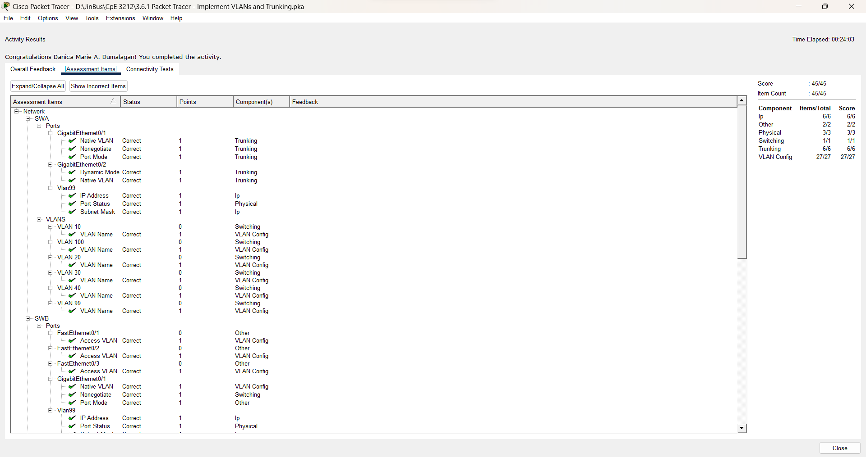

**Danica Marie A. Dumalagan**

**18103276**